Practical No 11

VIII. Resources required (Additional)
→ If any web resources required.

Resources used (Additional)
→ https://docs.microsoft.com/en-us/dotnet/api/system.windows.forms.toolstrip
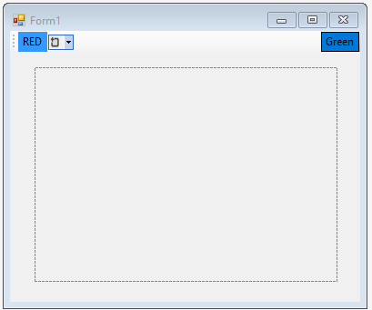→ https://docs.microsoft.com/en-us/dotnet/api/system.windows.forms.panel
→ https://docs.microsoft.com/en-us/dotnet/api/system.windows.forms.picturebox

Program Code
  - Write a program using Toolbar, Form and Panel Controls.
➢

Public Class Form1
Private Sub ToolStripButton1_Click(sender As Object, e As EventArgs) Handles ToolStripButton1.Click
Panel1.BackColor = Color.Red End Sub

Private Sub ToolStripButton2_Click(sender As Object, e As EventArgs) Handles ToolStripButton2.Click
Panel1.BackColor = Color.Green End Sub
End Class

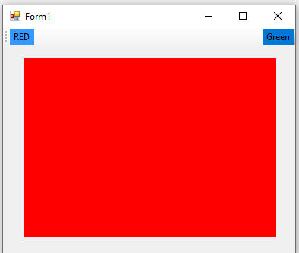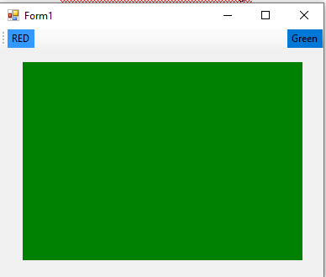Results (output of the program)

- Practical related Questions
  - List the controls which is used to set the icons on the Toolbar Control.
- Following Controls Can be added to ToolStrip / Toolbar.
Button, Label, DropDownButton, SplitButton, Separator, ComboBox, TextBox, and ProgressBar.

Difference between Form and Panel.
Windows Forms Panel controls are used to provide an identifiable grouping for other controls. Typically, you use panels to subdivide a form by function. The Panel control is similar to the GroupBox control; however, only the Panel control can have scroll bars, and only the GroupBox control displays a caption.

rcise
  - 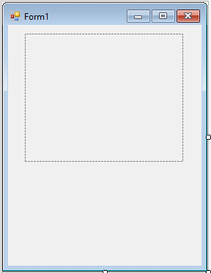Write program using picture box control to load an image at run time.
➢

Public Class Form1
Private Sub Form1_Load(sender As Object, e As EventArgs) Handles MyBase.Load PictureBox1.ImageLocation = "E:\www.studyroom.xyz\ON_Bulb.jpg" PictureBox1.SizeMode = PictureBoxSizeMode.AutoSize
End Sub End Class

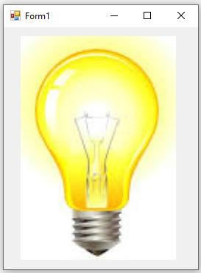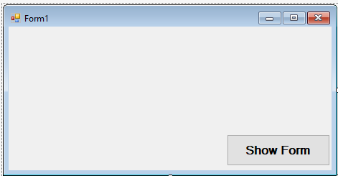OUTPUT:

  - Write a program to demonstrate the use of Panel Control in VB.Net.

Public Class Form1
Private Sub Button1_Click(sender As Object, e As EventArgs) Handles Button1.Click Dim dynamicPanel As New Panel()
dynamicPanel.Name = "Panel1"
dynamicPanel.Size = New System.Drawing.Size(228, 200) dynamicPanel.BackColor = Color.Pink

Dim textBox1 As New TextBox() textBox1.Location = New Point(10, 10) textBox1.Text = "Enter Your Name"

Dim checkBox1 As New CheckBox() checkBox1.Location = New Point(10, 50) checkBox1.Text = "Male" checkBox1.Size = New Size(200, 30)

Dim checkBox2 As New CheckBox() checkBox2.Location = New Point(10, 90) checkBox2.Text = "Male" checkBox2.Size = New Size(200, 30)

dynamicPanel.Controls.Add(textBox1)

dynamicPanel.Controls.Add(checkBox1) dynamicPanel.Controls.Add(checkBox2)

Controls.Add(dynamicPanel) End Sub
End Class

OUTPUT:

